 | Reading and Listening | TALK About IT! | Writing
Day 1 | Find a book about an animal (can be online)…listen or read. You could also research an animal on Pebble Go. | Talk to your mom and dad about what you learned.  A _______ can ________.  It eats _____________.  It lives _____________.  It’s covered with _______. | Make an “ALL ABOUT” poster of your animal… See if you can come up with 4 headings and write 3 key details under each heading in each box.  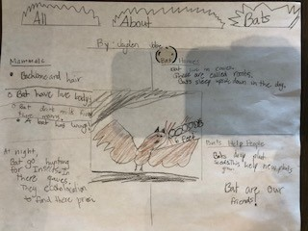
Day 2 | Rosetta Stone | Play a math dice game:  Roll two dice and multiply the numbers together. Say out loud:  6 times 2 equals 12  1 times 1 equals 1  Play with a sibling, parent, or friend:  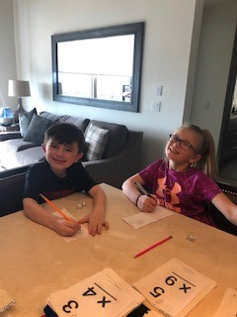 | Write out your math equations:  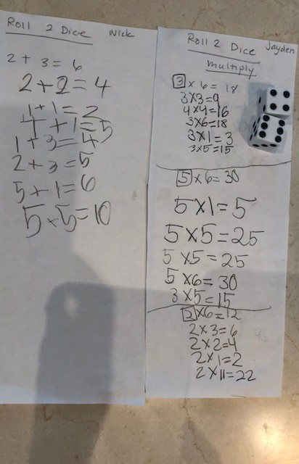
Day 3 | Reread your favorite Fiction story. | Retell the story using transition words:  I read the story _____ by __________. It was about (theme- what lesson does the reader or character learn).  First,___________.  Next, __________.  Then, __________.  Last, ___________.  I enjoyed this book because __________. | Write out the retell/summary. Make a flip book like we do in class with paper and scissors:  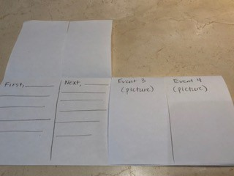  Your Introduction and final sentence can go on the back. Write the events inside and illustrate the front.
Day 4 |  | Review these fruits:  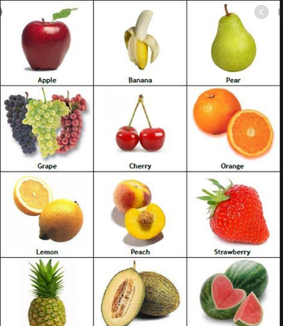  I like _______ but I don’t like __________.  My mom likes ______.  My dad likes ________.  He likes ___________.  She likes __________.  We like ____________.  They like___ but they don’t like ________.  Talk About It: | Make your own BOOK:  I LIKE__________ because _______.I DON’T LIKE ________ because ____.  - Write sentences about fruits you like and don’t like.  - How many pages can you make?  - Make a front cover with your name.  - Have your parent staple it.  - Read your book to your family.
Day 5 | Rosetta Stone Program | What is the same and what is different?  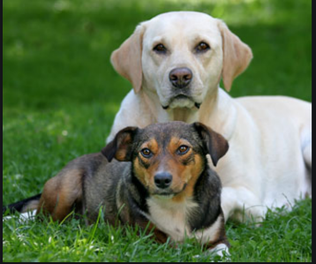  Both animals are ______.  Dog 1 is _________ but dog 2 is ___________. Another difference is _________________. As you can see, both dogs are _______________. | Write out your sentences and draw a picture. Add Color:  What is the same and what is different?  They are both _______.  Dog 1 is _________ but dog 2 is ___________. Another difference is ___________. As you can see, both dogs are _____________________.

